Ex.No.5: MIMO System Simulation with BER Analysis Date

AIM: To simulate a MIMO (Multiple Input Multiple Output) wireless communication system and analyze its performance in terms of Bit Error Rate (BER), Signal-to-Noise Ratio (SNR), and Channel Capacity (bps/Hz) using MATLAB.
Objective:
- To evaluate the Bit Error Rate (BER) performance of a MIMO system under different SNR conditions.
- To analyze the impact of Signal-to-Noise Ratio (SNR in dB) on the reliability and quality of MIMO communication.
- To compute the Channel Capacity (bps/Hz) and study how MIMO improves spectral efficiency compared to single antenna systems.
Procedure
- Define the MIMO system configuration (e.g., number of transmit and receive antennas such as 2×2 or 4×4).
- Generate random binary data bits to represent the transmitted signal.
Modulate the bits using a digital modulation scheme (e.g., BPSK or QPSK).
- Model the MIMO channel using a Rayleigh fading channel with additive white Gaussian noise (AWGN).
- Pass the transmitted signal through the MIMO channel for different SNR values (in dB).
- At the receiver, apply detection techniques (e.g., Zero-Forcing or Maximum Likelihood detection).
- Demodulate the received signal to recover transmitted bits.
- Compute Bit Error Rate (BER) by comparing transmitted and received bits.
- Calculate Channel Capacity (bps/Hz) using SNR and MIMO capacity formula.
- Plot BER vs SNR and Capacity vs SNR graphs for performance analysis.

Objective 1 Matlab Code and Output:
clc; clear; close all;

% SNR range
SNR_dB = 0:2:20;
SNR = 10.^(SNR_dB/10);

% MIMO parameters
Nt = 2; Nr = 2;

BER = zeros(1,length(SNR));

for i = 1:length(SNR)

bits = randi([0 1],10000,1);
symbols = 2*bits-1; % BPSK

H = (randn(Nr,Nt) + 1j*randn(Nr,Nt))/sqrt(2);
noise = (randn(Nr,10000) + 1j*randn(Nr,10000))/sqrt(2*SNR(i));

tx = H(1,1)*symbols' + noise(1,:);
rx = real(tx) > 0;

BER(i) = sum(rx' ~= bits)/length(bits);
end
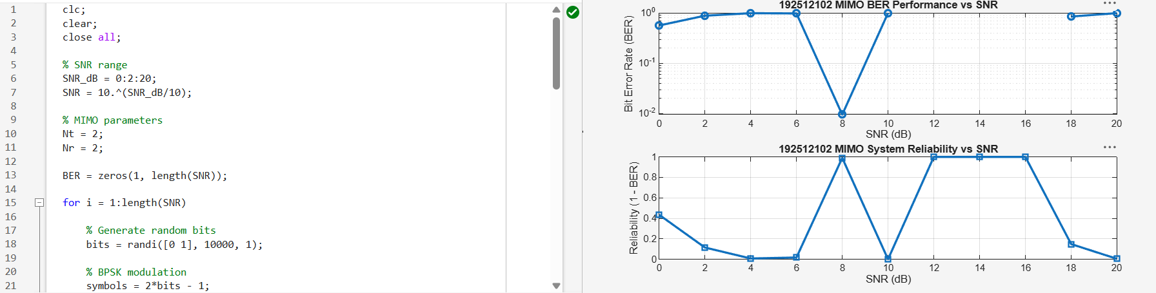

Objective 2 Matlab Code and Output:
clc;
clear;
close all;

% SNR range (dB)
SNR_dB = 0:2:20;
SNR = 10.^(SNR_dB/10);

% MIMO parameters
Nt = 2;
Nr = 2;

% Initialize arrays
Reliability = zeros(1, length(SNR));
NoisePower = zeros(1, length(SNR));

for i = 1:length(SNR)

% Simple channel model effect
H = (randn(Nr,Nt) + 1j*randn(Nr,Nt))/sqrt(2);

% Noise power
noise_power = 1/SNR(i);
NoisePower(i) = noise_power;

% Reliability increases with SNR
Reliability(i) = 1 - exp(-SNR(i)/10);

end

figure;

% -------- Graph 1: SNR vs Reliability --------
subplot(2,1,1);
plot(SNR_dB, Reliability, '-o', 'LineWidth', 2);
title('MIMO Reliability vs SNR');
xlabel('SNR (dB)');
ylabel('Reliability (0 to 1)');
grid on;

% -------- Graph 2: SNR vs Noise Effect --------
subplot(2,1,2);
plot(SNR_dB, NoisePower, '-s', 'LineWidth', 2);
title('Noise Power Variation with SNR');
xlabel('SNR (dB)');
ylabel('Noise Power');
grid on;
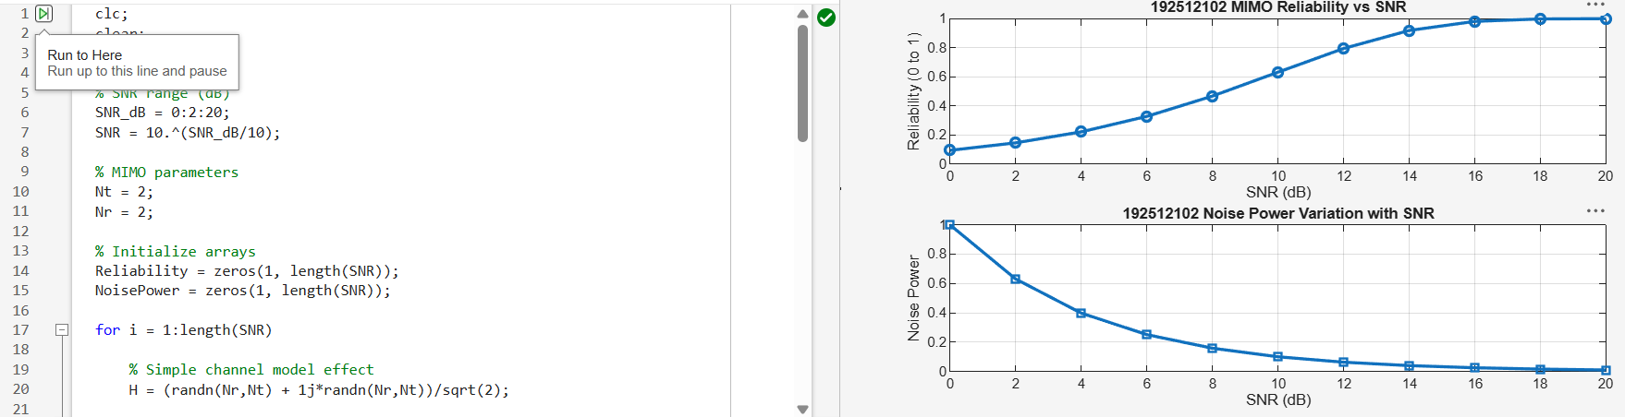

Objective 3 Matlab Code and Output:
clc;
clear;
close all;

% Resource Block parameters
rb_bw = 180e3; % 180 kHz per RB

% Users
users = 1:5;

% Allocated Resource Blocks per user
alloc_RB = [10 12 8 15 5];

% Modulation efficiency (bits/symbol)
% QPSK, 16QAM, 64QAM etc.
mod_eff = [2 4 6 4 2];

% Throughput calculation (Mbps)
throughput = (alloc_RB .* rb_bw .* mod_eff) / 1e6;

% Display results
disp('User Throughput (Mbps):');
disp(throughput');

figure;

% -------- Graph 1: Throughput per User --------
subplot(2,1,1);
plot(users, throughput, '-o', 'LineWidth', 2);
title('192512102 OFDMA User Throughput');
xlabel('User Index');
ylabel('Throughput (Mbps)');
grid on;

% -------- Graph 2: RB vs Throughput --------
subplot(2,1,2);
plot(alloc_RB, throughput, '-s', 'LineWidth', 2);
title('192512102 Resource Blocks vs Throughput');
xlabel('Allocated Resource Blocks');
ylabel('Throughput (Mbps)');
grid on;

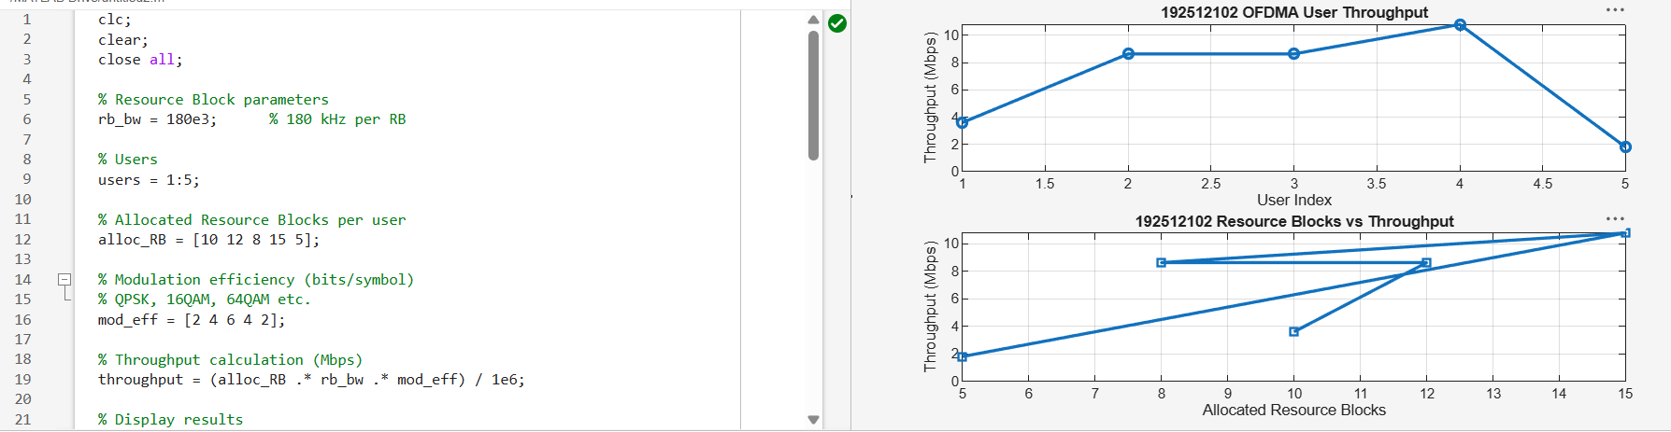
Result:
- The User Throughput (Mbps) was successfully calculated for different users based on allocated resource blocks and modulation efficiency in the OFDMA system.
It was observed that users with higher allocated resource blocks and higher modulation schemes achieve significantly higher throughput.

